**Upload a File in Microsoft Teams:**

1. Open Microsoft Teams and go to the chat or ‘group channel’ where you want to share the file.
2. On the top of chat, click on the Files button. 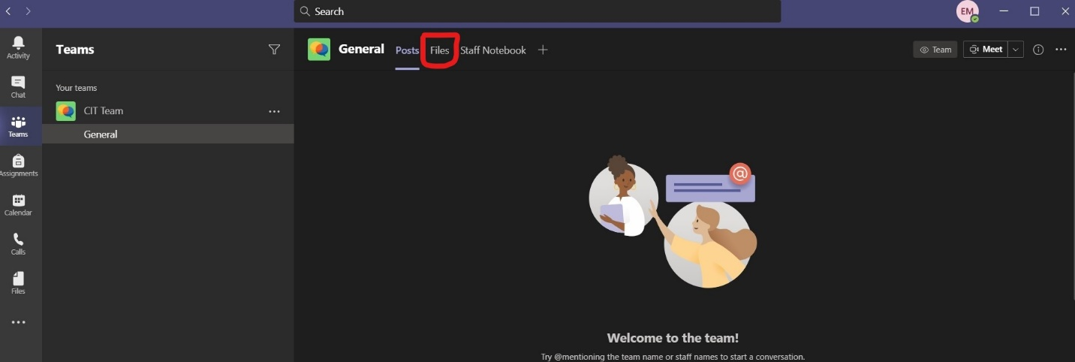
3. Navigate the files to the folder where you want to upload your file. Click Upload. 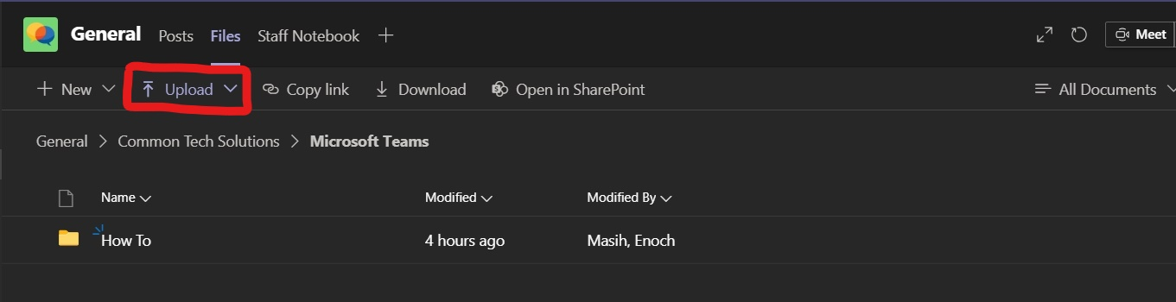
4. A drop-down option will be presented, click either the File or Folder to upload. 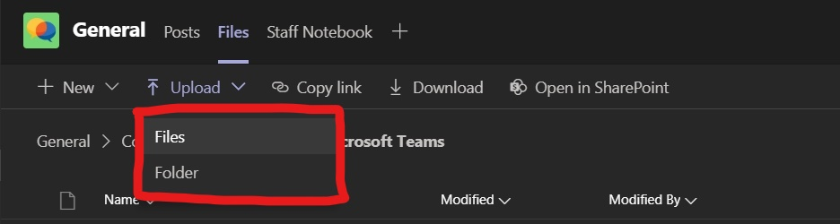
5. After selecting the file or folder, click open. Wait for uploading to begin. An uploading bar will be presented on the right side of Teams. 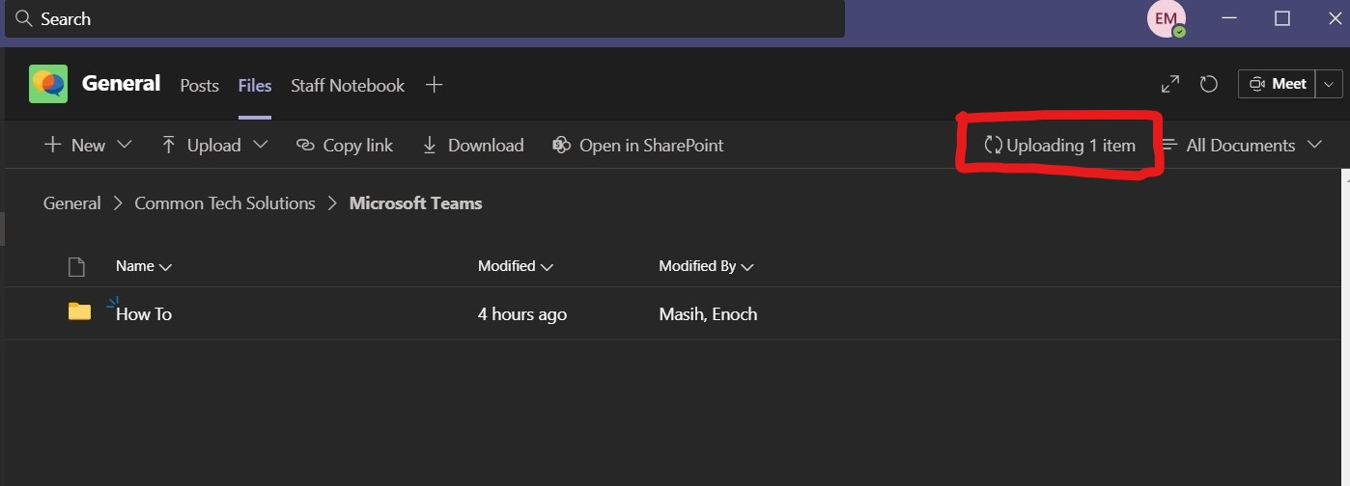

**Tips:**

* If you opened a file to view and decided to delete the file; Teams may present you with error ‘6009’. To avoid this, make sure to close the file (screenshot below) before deleting. Also make sure no other members of the group have the file open. 